AUTOMATIC RAILWAY GATE CONTROL SYSTEM USING IR SENSOR
Phase 3 — System Design Review
Submitted by, M HARINI, SM AKSHAYA, P THARANI LAKSHMI

1. System Architecture

1.1 Overall Solution Architecture
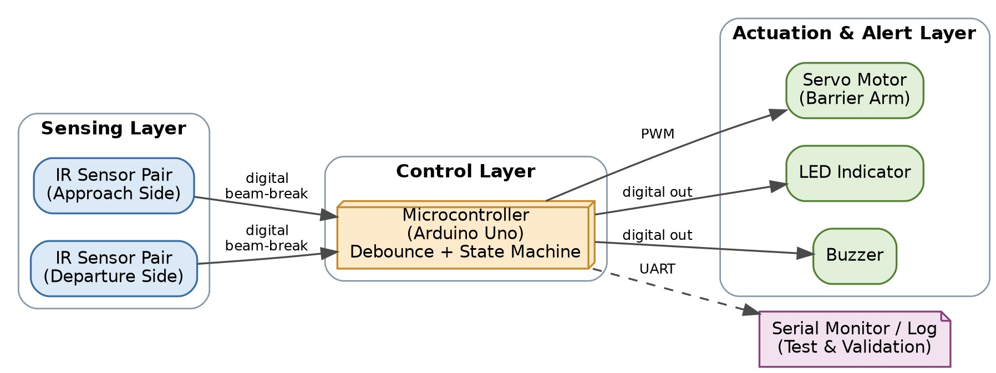
The system is organized into three layers, consistent with the dual-IR-sensor design proposed in Phase 2: a Sensing Layer (approach-side and departure-side IR sensor pairs), a Control Layer (an Arduino Uno running the debounce and gate state-machine logic defined in Section 3), and an Actuation & Alert Layer (the servo-driven barrier, LED, and buzzer). A Serial Monitor / Log path is included as a crosscutting element to support the testing and validation activity. Sensor signals enter the microcontroller as simple digital beam-break inputs; the microcontroller alone owns all timing and decision-making, which keeps the sensing and actuation hardware simple and low-cost.

1.2 Data Flow Diagram
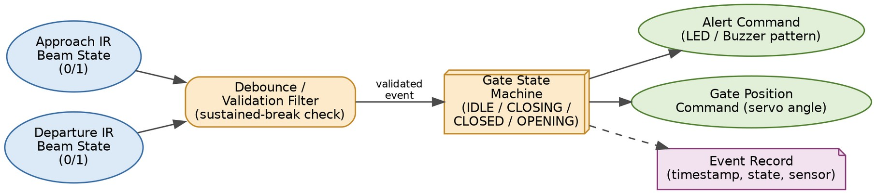
it traces a single unit of data — a beam-break event — from sensor to actuator. Both IR channels are continuously polled and passed through a common debounce/validation filter, which rejects any break shorter than the configured debounce threshold. Only a validated event reaches the gate state machine, which is the single source of truth for the current gate state (IDLE, ALERTING, CLOSING, CLOSED, or OPENING). The state machine independently drives three outputs: the alert command, the gate-position command, and an event record for the serial log, so that a fault in the logging path can never block gate operation or road-user alerting.

1.3 Functional Block Diagram
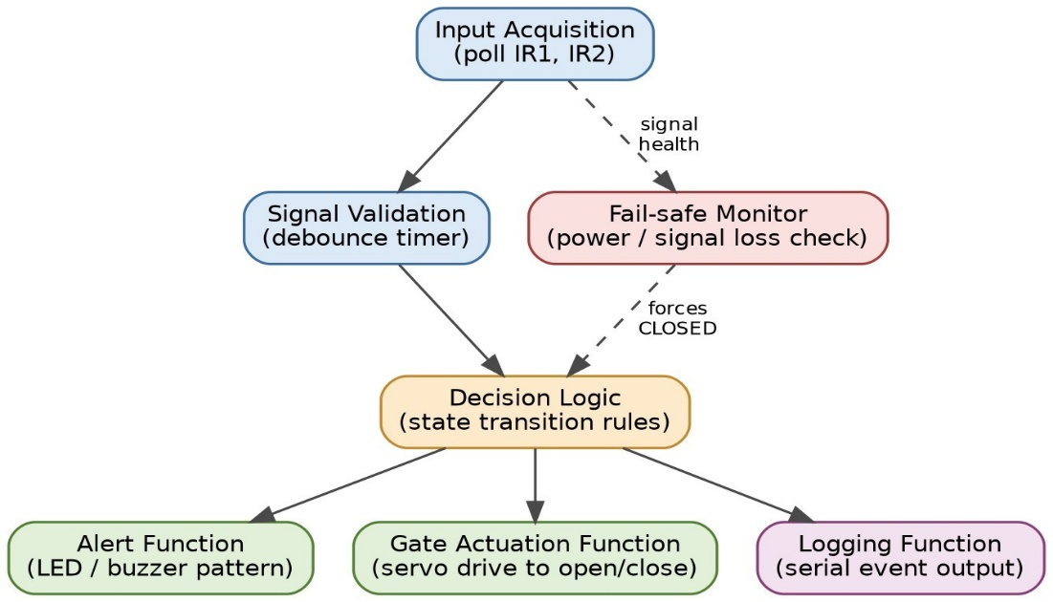
The functional decomposition mirrors the data flow but groups behaviour by responsibility rather than by data path. Input Acquisition and Signal Validation together implement debounce logic. A separate Fail-safe Monitor function, running independently of the main decision path, can force the state machine to CLOSED at any time if it detects a power or sensor-signal fault — this is the direct implementation of the fail-safe-default closed principle.

1.4 Hardware-Software Partitioning
Function | Partition | Rationale
IR beam generation & threshold comparison | Hardware (sensor module) | Fixed analog comparison is cheaper and faster in dedicated sensor hardware; the module exposes only a clean digital signal to the MCU.
Debounce timing & validation | Software (firmware) | Must be tunable rather than fixed  can be re-parameterized without any hardware change.
Gate state machine / decision logic | Software (firmware) | All functional requirements are sequencing/decision rules, naturally expressed in firmware and cheapest to change there.
Alert pattern generation | Software, via hardware | Pattern timing (continuous vs intermittent,
Function | Partition | Rationale
 | digital outputs | alerting ideas) can be changed in firmware without rewiring.
Physical gate motion | Hardware (servo + barrier arm) | Mechanical motion is inherently a hardware function; software only supplies the target angle via PWM.
Fail-safe default position | Hardware default + software fault check | Combines a software fault check with a hardware actuator command so the fallback does not depend on the same logic path that could have failed.
Event logging | Software (UART) over hardware USB-serial | Needed only for testing/validation, so kept as a lightweight, non-blocking feature that never gates real-time control.
This partitioning follows one governing principle: anything that must be tunable, testable, or changed without re-soldering lives in software on the Arduino Uno; anything inherently physical — beam generation/reception, barrier motion, audible/visible output — is left to purpose-built, low-cost hardware modules.

2. Hardware Design

2.1 Final Block Diagram
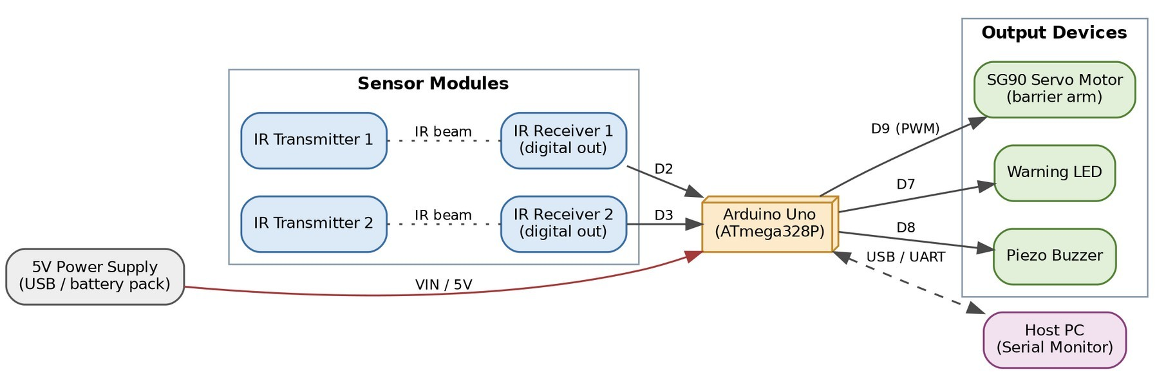
This finalizes the hardware selections carried into concrete parts and pin assignments: two independent IR transmitter/receiver pairs on digital pins D2 and D3, an SG90 micro servo on the PWM-capable pin D9, a warning LED on D7, and a piezo buzzer on D8. All modules share a common 5V rail and ground rail, and the Arduino's USB connection doubles as the serial log path to a host PC during testing, satisfying the logging function without any extra hardware.

2.2 Circuit Schematics
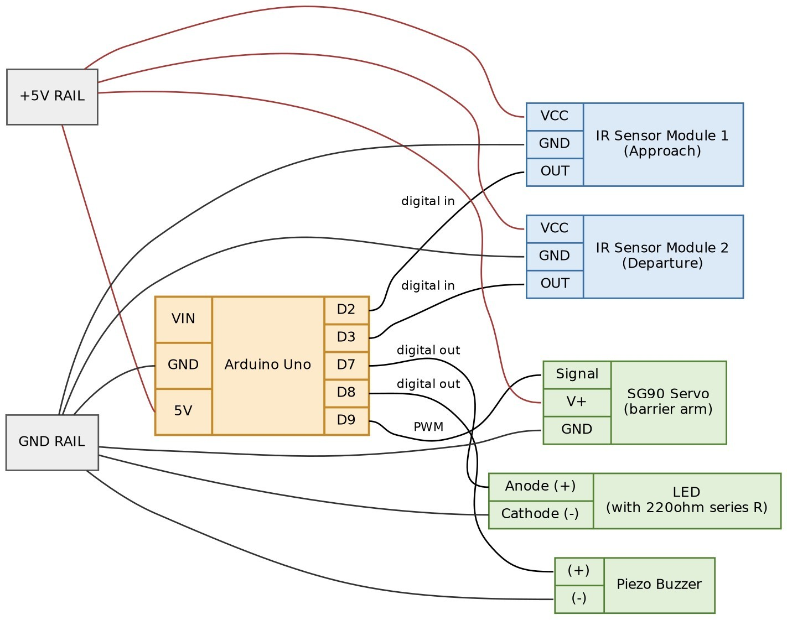
This shows module-level point-to-point wiring rather than a discrete-component electronic schematic, which is appropriate at this prototype stage since the IR sensors, servo, and buzzer are used as pre-built modules rather than discrete parts — consistent with the Arduino-class, module-based scope defined. The pin mapping is summarized below.
Signal | Arduino Pin | Direction | Notes
IR Sensor 1 OUT (Approach) | D2 | Input | digitalRead(); HIGH = beam intact, LOW = beam broken
IR Sensor 2 OUT (Departure) | D3 | Input | digitalRead(); HIGH = beam intact, LOW = beam broken
Servo signal | D9 | Output (PWM) | Servo.attach(9), driven via the Arduino Servo library
LED anode (via 220 ohm resistor) | D7 | Output | digitalWrite(); active-HIGH
Buzzer (+) | D8 | Output | digitalWrite(); active-HIGH
IR sensor VCC, Servo V+ | 5V rail | Power | Shared supply rail
All module grounds | GND rail | Common | Single-point ground to avoid ground loops

2.3 Component Selection
Component | Selected Part | Key Specification | Justification
Microcontroller | Arduino Uno (ATmega328P) | 16 MHz, 14 digital I/O (6  PWM), 5V logic | Carried forward from the Phase 1 Arduino/8051/PIC
Component | Selected Part | Key Specification | Justification
 |  |  | shortlist; built-in Servo library fits the student timeline.
Approach & departure sensors  (x2) | IR obstacle/beam-break sensor module | Digital output, adjustable sensitivity, ~5V supply | Matches the Phase 1/2 dual-IR-sensor baseline; digital output avoids onboard ADC handling in firmware.
Barrier actuator | SG90 micro servo | 180 deg range, ~0.1 s/60 deg speed, ~1.2-1.8 kg-cm stall torque @ 4.8-6V | Sufficient torque/speed for a lightweight prototype barrier arm; directly PWMcontrollable, a Phase 2 'Now' item.
Visual alert | 5mm high-brightness LED + 220 ohm series resistor | Forward current limited to ~15-20 mA | Low-cost, clearly visible under lab lighting.
Audible alert | 5V piezo buzzer | ~85 dB at 10 cm (moduletypical) | Inexpensive; satisfies the 'distinguishable and intuitive' usability NFR from Phase 2.
Power | USB 5V (bring-up) / 4xAA battery pack (untethered demo) | ≥1 A capacity | Covers combined peak draw of MCU, servo, and alert devices with margin.

2.4 Bill of Materials (BOM)
Item | Qty | Approx. Unit Price (INR) | Approx. Total (INR)
Arduino Uno (compatible board) | 1 | 500 | 500
IR obstacle sensor module | 2 | 100 | 200
5mm led | 1 | 4 | 4
220 ohm resistor | 1 | 1 | 1
Piezo buzzer | 1 | 15 | 15
Breadboard (half-plus size) | 1 | 120 | 120
Jumper wire set (M-M / M-F) | 1 set | 80 | 80
5v servo motor | 1 | 80 | 80
Approximate total: Rs. 1,000.

3.SoftwareDesign

3.1 Algorithms

Current State | Trigger Condition | Next State | Action Taken
IDLE | Approach beam broken, sustained ≥ T_debounce (150 ms) | ALERTING | Turn LED + buzzer ON; log transition
ALERTING | ALERT_LEAD time elapsed (250 ms) since alert start | CLOSING | None (timed transition only)
CLOSING | Immediate (single firmware pass) | CLOSED | Drive servo to 90 deg (closed); log transition
CLOSED | Departure beam broken, then restored | OPENING | None (transition only)
OPENING | Immediate (single firmware pass) | IDLE | Drive servo to 0 deg (open); LED + buzzer OFF; log transition
The debounce sub-algorithm underlying the IDLE-to-ALERTING transition is: while the approach beam reads broken, accumulate elapsed time in a timer; on any restoration of the beam, reset the timer to zero (rejecting the interruption); only when the accumulated time reaches T_debounce is the detection accepted as genuine. .
ARDUINO SOURCE CODE:
#include <Servo.h> // servo library
Servo s1;
int val = 0 ;
int va2 = 0 ;
void setup()
{
Serial.begin(9600); // sensor buart rate
pinMode(2,INPUT); // IR sensor 1
pinMode(3,INPUT); // IR sensor 2
s1.attach(9); // Servo Connect 9 pin
s1.write(0);
}
void loop()
{
val = digitalRead(2); // IR sensor 1 output pin connected
va2 = digitalRead(3); // IR sensor 2 output pin connected
Serial.println(val); // see the value in serial mpnitor in Arduino IDE
Serial.println(va2); // see the value in serial mpnitor in Arduino IDE
delay(10); // Time Delay
if(val == 1 )
{
s1.write(0); // SERVO 0 DEGREE
}
if(va2 == 1 )
{
s1.write(90); // SERVO 90 DEGREE
}
}

3.2 Communication Protocols
- Digital GPIO (parallel, point-to-point): used for both IR sensor inputs and the LED/buzzer outputs. Chosen because each device only needs a single-bit read or write.
- PWM, via the Arduino Servo library (built on Timer1 hardware PWM): used for the servo signal. The library abstracts the ~50 Hz, 1-2 ms pulse-width protocol RC-style servos.
- UART / Serial (9600 baud over USB-CDC): used exclusively for the event log described in Sections 1.2-1.3, one CSV-style line per state transition (timestamp, from-state, to-state, IR1, IR2). This is a diagnostic channel only, kept outside the control loop so a logging fault can never block gate operation.
No networked protocol (Wi-Fi, Bluetooth, GSM) and no external-IC bus (I2C/SPI) is used, consistent with the Phase 1 scope boundary that defers RFID/GSM/IoT extensions to future work.

Time (s) | Transition | IR1 (approach) | IR2 (departure)
3.14 | IDLE -> ALERTING | broken | intact
3.39 | ALERTING -> CLOSING | broken | intact
3.57 | CLOSING -> CLOSED | broken | intact
6.40 | CLOSED -> OPENING | intact | intact
6.58 | OPENING -> IDLE | intact | intact

References
- Arduino Official Documentation — Digital I/O, Servo Library, and Timer/PWM references, docs.arduino.cc.
- Wokwi Arduino Uno Simulator Documentation, docs.wokwi.com.
- TowerPro SG90 Micro Servo — manufacturer-typical specifications (180 deg range, ~0.1-0.12 s/60 deg operating speed, 4.8-6V).
- Generic IR obstacle/beam-break sensor module datasheet (digital-output type, adjustablethreshold comparator), as used in Phase 1/2 literature survey references [1]-[5].

